TASK 5 – Operators and precedence
The peak rule should be written as (hour >= 8 && hour < 10) || (hour >= 17 && hour < 20). The parentheses make the two time windows easy to read. The surcharge can be calculated with baseFare * 20 / 100 using integer paise. The conditional operator can select between two values, for example peak ? addSurcharge(base) : base.
Complete program supplied in the assignment
#include <iostream>
int main() {
int x = 5, y = 3;
std::cout << x + y * 2 << ' ' << (x + y) * 2 << '\n';
int z = x++ + ++y;
std::cout << z << ' ' << x << ' ' << y << '\n';
std::cout << (x > y ? x : y) << ' ' << x % 4 * 2 << '\n';
std::cout << 10 / 3 << ' ' << 10 % 3 << ' '
<< -10 / 3 << ' ' << -10 % 3 << '\n';
int k = 0;
for (int i = 0; i < 10; i += 3) k += i;
std::cout << k << '\n';
}

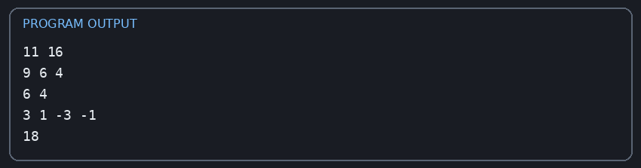
Actual output from the included execution:
11 16
9 6 4
6 4
3 1 -3 -1
18

Line 1: multiplication has higher precedence than addition, so 5 + (3*2) = 11; parentheses make (5+3)*2 = 16. Line 2: x++ contributes old x (5) and then increments x to 6; ++y increments y to 4 before contributing it; z is 9. Line 3: x is greater than y, so the conditional returns 6; modulo and multiplication are evaluated left to right at the same precedence, giving (6 % 4) * 2 = 4. Line 4: integer division truncates toward zero; remainders are 1 and -1. Line 5: i takes 0, 3, 6, 9, so k = 18.
Avoid i = i++ because modifying and reading the same scalar without a well-defined sequencing relationship can produce undefined behaviour. Prefix increment returns the incremented value; postfix returns the previous value.

Alternative concept and complexity
A bool peak[24] lookup table can mark each hour as peak or off-peak. Both the logical expression and array lookup are O(1) time. The table uses 24 bool elements (commonly 24 bytes, but verify sizeof(bool)); it may reduce repeated comparisons but adds a small amount of storage.

